Fish Facility Design Review Work Group (FFDRWG)

USACE, Portland District

# February 2021 Meeting Agenda

~~February 4, 2021 09:00-11:00~~

~~Join Meeting:~~ [~~https://usace1.webex.com/usace1/j.php?MTID=m5c365c1bf762dad74cbaa2985e8e04fb~~](https://usace1.webex.com/usace1/j.php?MTID=m5c365c1bf762dad74cbaa2985e8e04fb)

~~Meeting password: FFDRwG2021!~~

*~~(Log in through Webex and have the meeting call you)~~*

~~Phone-in only: (844) 800-2712 | Access Code: 199 571 1422~~

***(written updates only this month)***

## Introductions

Invited Attendees:

**BPA**

Scott Bettin

Kim Johnson

Siena Lopez-Johnston

Christine Petersen

Greg Smith

Leah Sullivan

**NOAA**

Blane Bellerud

Gabriel Brooks

Trevor Conder

Kinsey Frick

Claire McGrath

Josie Thompson

Kinsey Frick

Logan Negherbon

**USFWS**

Dave Swank

**States**

Erick Van Dyke (ODFW)

Charles Morrill (WDFW)

**CRITFC/Tribes**

Casey Baldwin (Colville)

Tom Lorz (CRITFC)

Blaine Parker (CRITFC)

Tom Skiles (CRITFC)

Michael Karnosh (CTGR)

Lawrence Schwabe (CTGR)

Torey Wakeland (CTGR)

Aaron Jackson (CTUIR)

Ralph Lampman (YN)

**NPCC**

Leslie Bach

Kris Homel

**FPC**

Erin Cooper (FPC)

**PSMFC**

Alan Brower

Darren Chase

Roger Clark

Mark Leonard

Scott Livingston

Nicole Tancreto

Don Warf

**CENWD**

Doug Baus

Tim Dykstra

Dan Feil

Mike Langeslay

Cindy Studebaker

Sean Tackley

Lisa Wright

**CENWW**

Karl Anderson

Christopher Peery

Marvin Shutters

**CENWP-OD**

Andrew Derugin

Leif Halvorson

Ben Hausmann

Bob Cordie

Jeffrey Randall

Scott Fielding

Eric Grosvenor

Michael Lotspeich

Erin Kovalchuk

Tammy Mackey

Darren Gallion

Nathan McClain

Robert Wertheimer

**CENWP-PM**

Jim Adams

Eric Bluhm

Ian Chane

Jeff Hicks

Valerie Higdon

Steve Sipe

Mike Turaski

Bob Winters

Brad Eppard

David Griffith

Fenton Khan

Rachel Laird

Jacob Macdonald

Rich Piaskowski

Jon Rerecich

Ida Royer

David Trachtenbarg

Andy Traylor

Jeremiah Woodard

**CENWP-ENC**

Bridget Bell

Jonathon Brink-Roby

Shari Dunlop

Laurie Ebner

Dan Jensen

Curtis Lipski

Chris Motti

Stephen Schlenker

Max Wilson-Fey

## Action items from last meeting

* Approve December and January minutes (Macdonald)
* Can the B2 FGE contractor work 7 days a week if needed? Bridget Bell will follow up with and e-mail to Charlie and/or group.

**UPDATE:** **The contract does not prohibit the contractor from working 7 days a week if they are within the fatigue management plan requirements.**

## Ongoing project updates

* JDA North Fish Ladder Variable Width Weir modification – Eric Bluhm (PM), Eric Grosvenor (JDA), Jacob Macdonald (FC)
* JDA North Fish Ladder LPS water supply upgrade – Eric Bluhm (PM), Jonathon Brink-Roby (TL), Jacob Macdonald (FC)
* JDA turbine rehab – Steve Sipe (PM), Curtis Lipski (TL), Jon Rerecich (FC)
* BON spillway rock removal [prevention] – Jeremiah Woodard (PM), Max Wilson-Fey/Chris Motti (TL), Ida Royer/Andrew Derugin (FC)
* BON Second Powerhouse FGE – Jim Adams (PM), Bridget Bell (TL), Jon Rerecich (FC)

* BON LPS pump upgrades – Bob Winters (PM), Ben Hausmann (TL)
* BON Cascades Island LPS flume modifications – Bob Winters (PM), Ben Hausmann (TL), Jacob Macdonald (FC)
* BON minor adult lamprey passage improvements – Bob Winters (PM), Ben Hausmann (TL), Jacob Macdonald (FC) 
  + Cascades Island upper leads

## New and upcoming project introductions

* TDA AWS Trash Rake – Ida Royer (PM), Erica Tarbox (TL), TBD (FC)
* BON Washington Shore control section redesign – Bob Winters (PM), Shari Dunlop (TL), Jacob Macdonald (FC)
* BON Bradford Island Ladder extensive minor modifications to serpentine section for lamprey – Bob Winters (PM), __ (TL), Jacob Macdonald (FC)
* BON Bradford Island B-Branch entrance improvements (variable width entrance weir, bollards, and transition pool LPS) – Bob Winters (PM), __ (TL), __ (FC)
* BON Washington Shore transition pool LPS – Bob Winters (PM), __ (TL), __ (FC)
* TDA East Fish Ladder transition pool LPS – Eric Bluhm (PM), __ (TL), __ (FC)
* TDA East Fish Ladder control section weir modifications for lamprey – Eric Bluhm (PM), __ (TL), __ (FC)
* JDA South Ladder entrance improvements (rounded crest, slot filler) – Eric Bluhm (PM), __ (TL), __ (FC)

## Additional topics

Next meeting: March 4th @ 0900

Link to FFDRWG folder:

<http://www.nwd-wc.usace.army.mil/tmt/documents/FPOM/2010/FFDRWG/FFDRWG.html>

Fish Facility Design Review Work Group (FFDRWG)

USACE, Portland District

Project Update

Date Prepared: 2021-01-28

# JDA North Fish Ladder Variable Width Weir Improvement

|  |  |
| --- | --- |
| Project Identifier: | P2 # 492402 |
| Project Manager (PM): | Eric Bluhm (CENWP-PM-FP)  *Eric.V.Bluhm@usace.army.mil* |
| Technical Lead (TL): | Eric Grosvenor (CENWP-ODJ)  *Eric.Grosvenor@usace.army.mil* |
| FFDRWG Coordination (FC): | Jacob Macdonald (CENWP-PME)  *Jacob.Macdonald@usace.army.mil* |

## Project Description

Replace the skin on the downstream face of the JDA North Fish Ladder Variable Width Weir (VWW) with material that will provide a smooth attachment surface for lamprey. The VWW was originally constructed in 2013 using HDPE panels on the downstream face, either to save weight or cost. Some HDPE panels have since failed and were temporarily replaced with screen material.

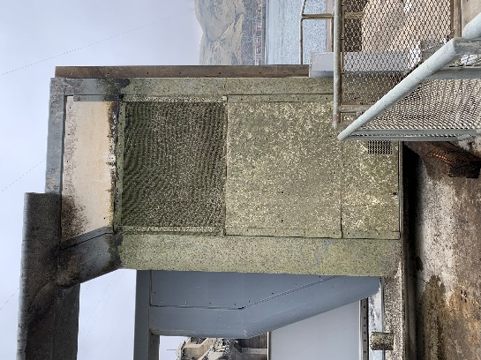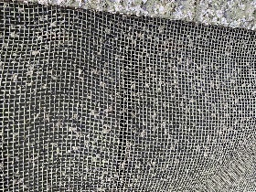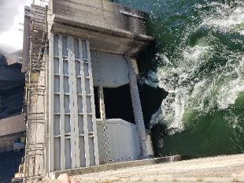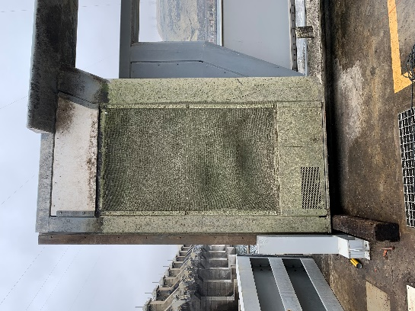

## Project Schedule

Design: FY 2021

Construction: Winter 2021/2022 or Winter 2022/2023

Evaluation/Closeout: FY 2022 or FY 2023

## Current Status

VWW is in place with JBS screen panels (as pictured above) awaiting design and fabrication.

## Topics for FFDRWG Review/Coordination

None currently.

Fish Facility Design Review Work Group (FFDRWG)

USACE, Portland District

Project Update

Date Prepared: 2021-01-28

# JDA North Fish Ladder LPS water supply upgrade

|  |  |
| --- | --- |
| Project Identifier: | P2 # 492402 |
| Project Manager (PM): | Eric Bluhm (CENWP-PM-FP)  *Eric.V.Bluhm@usace.army.mil* |
| Technical Lead (TL): | Jonathon Brink-Roby (CENWP-ODJ)  *Jonathon.C.Brink-Roby@usace.army.mil* |
| FFDRWG Coordination (FC): | Jacob Macdonald (CENWP-PME)  *Jacob.Macdonald@usace.army.mil* |

## Project Description

Increase the capacity of the current system.

1. Modify LPS to replace existing drop in well pumps with gravity-fed water supply or alternative, more reliable pump configuration.
2. Larger collection box (current water supply is insufficient so larger box cannot be installed without upgraded water supply.
3. Consider opportunities for volitional passage in the design

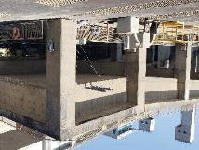 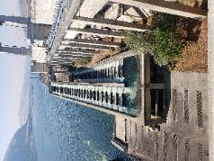 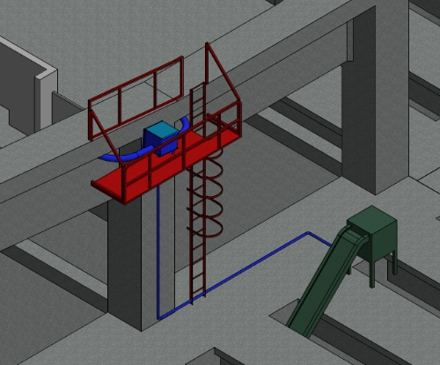

## Project Schedule

Design: FY 2021

Construction: Winter 2021/2022

Evaluation/Closeout: FY 2022

## Current Status

PDT is preparing multiple alternatives for consideration. LPS is in service for 2021 passage season with existing pumps and collection box.

## Topics for FFDRWG Review/Coordination

None currently.

Fish Facility Design Review Work Group (FFDRWG)

USACE, Portland District

Project Update

Date Prepared: 2021-01-28

# JDA Turbine Rehab

|  |  |
| --- | --- |
| Project Identifier: | P2 # |
| Project Manager (PM): | Steve Sipe (CENWP-PMF-P)  *Steven.C.Sipe@usace.army.mil* |
| Technical Lead (TL): | Curtis Lipski (CENWP-ENC-HD)  *Curtis.L.Lipski@usace.army.mil* |
| FFDRWG Coordination (FL): | Jon Rerecich (CENWP-PME)  *Jonathan.G.Rerecich@usace.army.mil* |

## Project Description

The purpose of this project is to address reliability concerns and maximize production of hydroelectric power at JDA, which includes electrical energy production and electrical grid ancillary services while at the same time, improving survival of fish passing through the turbines. Maximum production of hydroelectric power at JDA will be realized through increased reliability and increased efficiency. Reliability improvements will be realized through a combination of replacement and refurbishment of powertrain equipment to include, but not limited to, turbine runners, shafting, generators, isophase bus, breakers, switches, and transformers. Efficiency improvements will be realized through increased turbine efficiencies associated with new turbine runners and other modifications to the turbines.

The purpose of this project is also to increase survival of turbine passed fish. Increased survival of turbine passed fish will be realized through developing state-of-art hydroelectric turbines to obtain improved fish passage survival through the turbines. The design of the state-of-the-art turbines will be an iterative and collaborative process that focuses on fish-friendly design features and criteria. This iterative and collaborative design process will be similar to the ongoing Ice Harbor L&D turbine runner replacement design and upcoming McNary L&D turbine runner replacement in NWW. Phase 1A recommendations include replacing up to 14 units with combination fixed blade & adjustable blade to obtain improved fish passage survival through the turbines.

## Project Schedule

|  |  |  |
| --- | --- | --- |
| Phase 1 Short Term Schedule | Start | Finish |
| 30% DDR/P&S review | 3/12/2020 | 4/1/2020 |
| 60% DDR/P&S review | 8/28/2020 | 9/18/2020 |
| 90% DDR/P&S review | 9/21/2021 | 2/18/2022 |
| BCOES review | 1/24/2022 | 11/11/2022 |

|  |  |
| --- | --- |
| Overall Schedule Milestones | Date |
| Contract award | October 2024 |
| Collaborative design process Model testing | 2024-2029 |
| First unit installation | 2031-2033 |
| Unit installation complete | 2040-2045 |

## Current Status

* Final VE study report due Feb. 19, 2021
* The 1:25 scale physical observational turbine model rehab and relocation is complete. The model will be used to inform the development of the Phase 1 Plans and Specifications package, to document the hydraulic conditions that affect the biological performance of the existing JDA turbines, and to support the collaborative and iterative design process in Phase 2. ERDC baseline model validation testing with the existing runner has been scheduled for last week and this week. Baseline model data collection for Test Series 1 will be occurring until May 2021 at which time ERDC is scheduled to transition back to McNary. This task includes preparation of a data report documenting the runs performed, results, conclusions, and recommendations. Runner evaluation tests will need to carry over to Test Series 2 (not yet scoped), which is expected to occur in late 2021 or early 2022.
* Tailrace flow patterns have been validated in the 1:45 JDA general model and in a CFD model. Model runs will commence after further HAC modeling is complete and preliminary options for the turbine mix are established. The focus of the tailrace modeling will be to assess juvenile egress and conditions for adult approach to the fish ladder entrances.

## Topics for FFDRWG Review/Coordination

None currently.

Fish Facility Design Review Work Group (FFDRWG)

USACE, Portland District

Project Update

Date Prepared: 2021-01-28

# BON Spillway Rock Removal [prevention]

|  |  |
| --- | --- |
| Project Identifier: | P2 # 470163 |
| Project Manager (PM): | Jeremiah Woodard (CENWP-PMF-P)  *Jeremiah.J.Woodard@usace.army.mil* |
| Technical Lead (TL): | Christopher Motti (CENWP-ENC-HD)  *Christopher.S.Motti@usace.army.mil* |
| FFDRWG Coordination (FC): | Ida Royer / Andrew Derugin (CENWP-PME)  [*Ida.M.Royer@usace.army.mil*](mailto:Ida.M.Royer@usace.army.mil) */ Andrew.G.Derugin@usace.army.mil* |

## Project Description

This project is to determine whether a structural alternative can be identified to prevent rocks from moving into the stilling basin of Bonneville Dam. Currently emergency contracts are placed most years (four out of five since 2011) to physically remove rocks from the stilling basin. Alternatives will be evaluated based on factors such as their ability to prevent rock movement, cost, and ease of construction.

## Project Schedule

A Phase IA report is scheduled to be completed at the end of September 2021.

## Current Status

CFD modeling, ERDC physical modeling are complete. The modeling results are still being analyzed and formed into a modeling report.

## Topics for FFDRWG Review/Coordination

None currently.

Fish Facility Design Review Work Group (FFDRWG)

USACE, Portland District

Project Update

Date Prepared: 2021-01-28

# BON Second Powerhouse FGE

|  |  |
| --- | --- |
| Project Identifier: | P2 # |
| Project Manager (PM): | Jim Adams (CENWP-PMF)  *James.R.Adams@usace.army.mil* |
| Technical Lead (TL): | Bridget Bell (CENWP-ENC)  *Bridget.M.Bell@usace.army.mil* |
| FFDRWG Coordination (FL): | Jon Rerecich (CENWP-PME)  *Jonathan.G.Rerecich@usace.army.mil* |

## Project Description

Steel plates were installed in all units in the A and B gatewells to restrict flow. During routine inspections, however, it became apparent that the anchoring system for the steel plates was inadequate. In effect, the nuts and anchoring bolts holding down the plates had come lose, posing the risk that the plates could detach and potentially take out a unit. All flow restriction plates were removed from the units.

A concrete corbel will be installed in the same location as the flow control plates with the design goal to achieve similar gatewell hydraulic conditions as the flow control plates. This new concrete corbel has been designed to meet the flow criteria established and tested for the previous flow restrictor plates to meet the hydraulic and biological goals.

## Project Schedule

* Awarded 21 December 2020 to Northbank Civil and Marine. Notice to proceed 29 December 2020.

|  |  |  |  |  |
| --- | --- | --- | --- | --- |
| CLIN | Status | Description | Award/Exercise Date | Construction Execution Window |
| 1 | Mandatory | Mobilization/Demobilization | December 2020 Award |  |
| 2 | Mandatory | Unit 15 Construction | December 2020 Award | February 2021-April 2021 |
| 3 | Optional | Second Mob/Demob and Unit 11 Construction | Sept. 30, 2021 | Dec 2021-Feb 2022 |
| 4 | Optional | 2 Additional Units | Sept. 30, 2021 | Extend through May 2022 |
| 5 | Optional | 2 Additional Units | Nov. 30, 2021 | Extend through August 2022 |
| 6 | Optional | 2 Additional Units (Unit 18 + 1 more Unit) | Nov. 30, 2021 | Extend through February 2023 |

* Construction in unit 15 to be in early spring of 2021. Unit 15 is on the outage schedule March 1-April 20. The contract states the unit must be completed by April 15th.
* Hydraulic Testing Spring 2021 – dependent on flows. We plan to be ready for testing by as early

as mid-May. The A/E testing contract is expected to be awarded soon. A more detailed test schedule will follow.

* Evaluation of testing results late summer 2021. We expect to be able to move on to additional units starting in the late fall of 2021 if the testing results prove acceptable.

## Current Status

2021 Fish Passage Plan, Draft Appendix A, contains the special operations for hydraulic testing. More details on the schedule and calendar dates will be provided as we coordinate with the contractor and get closer to testing.

## Topics for FFDRWG Review/Coordination

None currently. Testing results will be reviewed with FFDRWG in late summer 2021 to determine if hydraulic objectives have been met.

Fish Facility Design Review Work Group (FFDRWG)

USACE, Portland District

Project Update

Date Prepared: 2021-01-28

# BON Lamprey Passage Structure Pump Upgrade

|  |  |
| --- | --- |
| Project Identifier: | P2 # 492400 and 492401 |
| Project Manager (PM): | Bob Winters (CENWP-PM-FP)  *Robert.Winters@usace.army.mil* |
| Technical Lead (TL): | Ben Hausmann (CENWP-ODB)  *Benjamin.J.Hausmann@usace.army.mil* |
| FFDRWG Coordination (FC): | Jacob Macdonald / Andrew Derugin (CENWP-PME)  *Jacob.Macdonald@usace.army.mil / Andrew.G.Derugin@usace.army.mil* |

## Project Description

Bradford Island, Cascades Island, and Washington Shore LPS's will have current drop in well pumps replaced with standardized 480V surface mount pumps that will increase the reliability and flexibility of the Bonneville Dam LPS system.

## Project Schedule

* Acquire Materials: FY 2021
* Installation: WA Shore and Cascades Island – FY 2021, Bradford Island – Winter 2021/2022
* Evaluation/Closeout: FY 2022

## Current Status

Project staff are ordering pumps and will install them upon delivery.

## Topics for FFDRWG Review/Coordination

None currently.

Fish Facility Design Review Work Group (FFDRWG)

USACE, Portland District

Project Update

Date Prepared: 2021-01-28

# BON Cascades Island LPS Flume modifications

|  |  |
| --- | --- |
| Project Identifier: | P2 # 492401 |
| Project Manager (PM): | Bob Winters (CENWP-PM-FP)  *Robert.Winters@usace.army.mil* |
| Technical Lead (TL): | Dan Costan (CENWP-ODB)  *Laurentiu.D.Costan@usace.army.mil* |
| FFDRWG Coordination (FC): | Jacob Macdonald / Andrew Derugin (CENWP-PME)  *Jacob.Macdonald@usace.army.mil / Andrew.G.Derugin@usace.army.mil* |

## Project Description

Lamprey flume needs to be lowered to eliminate the mid-system lift pumps. This may require rerouting existing plumbing and moving electrical equipment in the area, as well as fabricating new brackets and a new flume section.

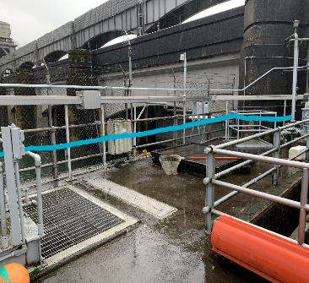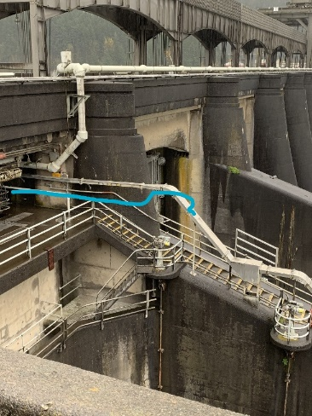

## Project Schedule

* Design: FY 2021
* Construction: FY 2021 (or FY 2022)
* Evaluation and Closeout: FY 2022

## Current Status

Initiating design.

## Topics for FFDRWG Review/Coordination

None currently.

Fish Facility Design Review Work Group (FFDRWG)

USACE, Portland District

Project Update

Date Prepared: 2021-01-28

# BON Cascades Island upper picketed lead modification

|  |  |
| --- | --- |
| Project Identifier: | P2 # 492401 |
| Project Manager (PM): | Bob Winters (CENWP-PM-FP)  *Robert.Winters@usace.army.mil* |
| Technical Lead (TL): | Ben Hausmann (CENWP-ODB)  *Benjamin.J.Hausmann@usace.army.mil* |
| FFDRWG Coordination (FC): | Jacob Macdonald / Andrew Derugin (CENWP-PME)  *Jacob.Macdonald@usace.army.mil / Andrew.G.Derugin@usace.army.mil* |

## Project Description

Modify two upper picket leads (upstream of new LPS trap) to exclude lamprey from AWS Channel. Replace existing leads with smaller mesh and eliminate gaps to prevent lamprey from straying into the dead-end abandoned AWS channel.

## Project Schedule

* Installation: February 2021
* Evaluation/Closeout: FY 2021

## Current Status

OD-B project staff are scheduled to perform this minor modification while the ladder is dewatered for maintenance through February 2021.

## Topics for FFDRWG Review/Coordination

None currently.

Fish Facility Design Review Work Group (FFDRWG)

USACE, Portland District

Project Update

Date Prepared: 2021-01-28

# TDA AWS trash rake

|  |  |
| --- | --- |
| Project Identifier: | P2 # |
| Project Manager (PM): | Ida Royer (CENWP-PMF)  *Ida.M.Royer@usace.army.mil* |
| Technical Lead (TL): | Erica Tarbox (CENWP-ENC)  *Erica.M.Tarbox@usace.army.mil* |
| FFDRWG Coordination (FC): | TBD |

## Project Description

## This project is to evaluate alternatives to remove debris from The Dalles Dam Auxiliary Water Supply (AWS) trash rack. Debris build-up on the rack currently causes high head differential across the rack.

## Project Schedule

TBD

## Current Status

New Startup. PM and TL have been assigned. Kickoff meeting is being scheduled and team members will be assigned.

## Topics for FFDRWG Review/Coordination

None currently. PDT will solicit FFDRWG review during the Engineering Design Report (EDR) process.

Fish Facility Design Review Work Group (FFDRWG)

USACE, Portland District

Project Update

Date Prepared: 2021-01-28

# BON Washington Shore control section redesign

|  |  |
| --- | --- |
| Project Identifier: | P2 # 492401 |
| Project Manager (PM): | Bob Winters (CENWP-PM-FP)  *Robert.Winters@usace.army.mil* |
| Technical Lead (TL): | Shari Dunlop (CENWP-ENC)  *Shari.L.Dunlop@usace.army.mil* |
| FFDRWG Coordination (FC): | Jacob Macdonald (CENWP-PME)  *Jacob.Macdonald@usace.army.mil* |

## Project Description

Modify the serpentine-style flow control section of Bonneville Dam’s Washington Shore fish ladder, converting it to an Ice Harbor-style vertical slot with submerged orifice configuration. See CRSO EIS §7.6.2.17.

## Project Schedule

TBD

## Current Status

New Startup. PM and TL have been assigned. Kickoff meeting February 2021.

## Topics for FFDRWG Review/Coordination

None currently. PDT will solicit FFDRWG for initial design considerations at the next meeting (4-March).

Fish Facility Design Review Work Group (FFDRWG)

USACE, Portland District

Project Update

Date Prepared: 2021-01-28

# BON Bradford Island Ladder extensive minor modifications to serpentine section for lamprey

|  |  |
| --- | --- |
| Project Identifier: | P2 # 492400 |
| Project Manager (PM): | Bob Winters (CENWP-PM-FP)  *Robert.Winters@usace.army.mil* |
| Technical Lead (TL): | TBD |
| FFDRWG Coordination (FC): | Jacob Macdonald (CENWP-PME)  *Jacob.Macdonald@usace.army.mil* |

## Project Description

Extensive minor modifications to control section (serpentine weirs) of ladder including refuge boxes, rounded corners on weirs, additional lamprey orifices, and (if practicable) new features such as artificial rocks.

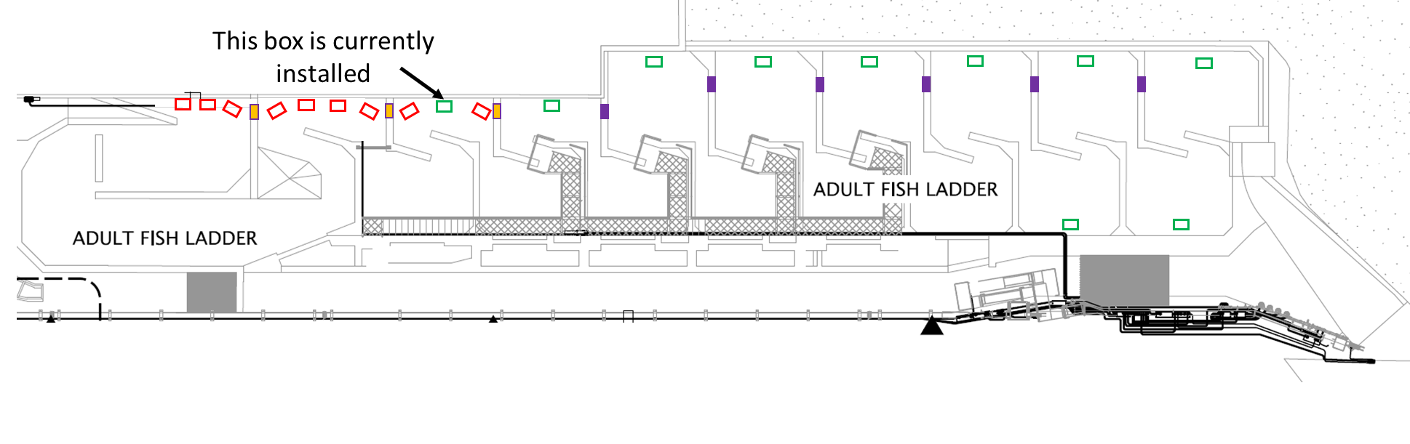 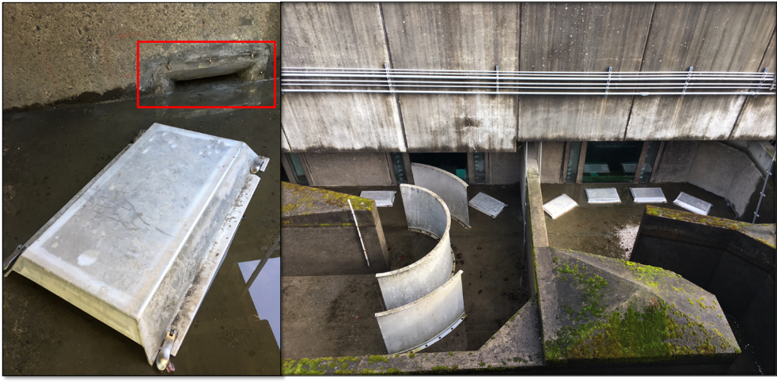

## Project Schedule

TBD

## Current Status

New Startup.

## Topics for FFDRWG Review/Coordination

None currently.

Fish Facility Design Review Work Group (FFDRWG)

USACE, Portland District

Project Update

Date Prepared: 2021-01-28

# BON Bradford Island B-Branch entrance improvements (variable width entrance weir, bollards, and transition pool LPS)

|  |  |
| --- | --- |
| Project Identifier: | P2 # 492400 |
| Project Manager (PM): | Bob Winters (CENWP-PM-FP)  *Robert.Winters@usace.army.mil* |
| Technical Lead (TL): | TBD |
| FFDRWG Coordination (FC): | Jacob Macdonald (CENWP-PME)  *Jacob.Macdonald@usace.army.mil* |

## Project Description

Design B-Branch (Spillway) entrance improvements, including variable width weir, bollards, refuge boxes or other cover, as feasible. Implement in conjunction with transition pool LPS at this fishway.

* Modeled after Cascades Island and JDA North (mirror image of Cascades Island Entrance)

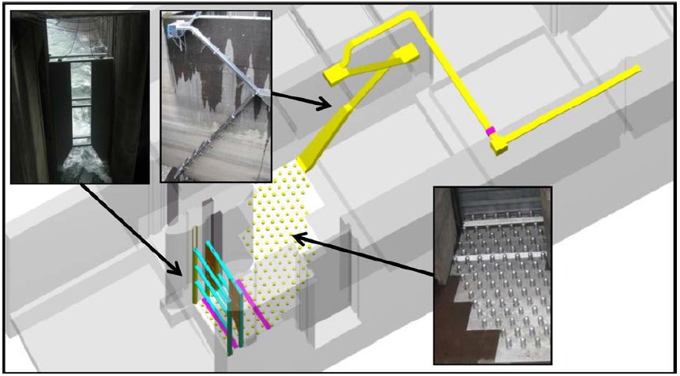

*Cascades Island entrance improvements (2009)*

## Project Schedule

TBD

## Current Status

New Startup.

## Topics for FFDRWG Review/Coordination

None currently.

Fish Facility Design Review Work Group (FFDRWG)

USACE, Portland District

Project Update

Date Prepared: 2021-01-28

# BON Washington Shore transition pool LPS

|  |  |
| --- | --- |
| Project Identifier: | P2 # 492401 |
| Project Manager (PM): | Bob Winters (CENWP-PM-FP)  *Robert.Winters@usace.army.mil* |
| Technical Lead (TL): | TBD |
| FFDRWG Coordination (FC): | Jacob Macdonald (CENWP-PME)  *Jacob.Macdonald@usace.army.mil* |

## Project Description

Design Transition Pool LPS to tailrace deck collection box.

CRSO EIS§7.6.2.20 : “Ramp-like flume structures would be installed or modified in fish ladders at Bonneville, The Dalles, and John Day dams to guide adult lamprey out of fish ladders and into parallel systems for volitional passage or collection for upstream transport or passage studies. The LPSs would use independent water sources (pumps or gravity-flow systems) and may be placed in various locations within fish ladders, such as collection channels, junction pools, or auxiliary water supply channels.

## Project Schedule

* Design: FY 2021 – FY 2022
* Construction: Winter 2022/2023
* Evaluation/Closeout: FY 2023

## Current Status

New Startup.

## Topics for FFDRWG Review/Coordination

None currently.

Fish Facility Design Review Work Group (FFDRWG)

USACE, Portland District

Project Update

Date Prepared: 2021-01-28

# TDA East Fish Ladder transition pool LPS

|  |  |
| --- | --- |
| Project Identifier: | P2 # 492403 |
| Project Manager (PM): | Eric Bluhm (CENWP-PM-FP)  *Eric.V.Bluhm@usace.army.mil* |
| Technical Lead (TL): | TBD |
| FFDRWG Coordination (FC): | Jacob Macdonald (CENWP-PME)  *Jacob.Macdonald@usace.army.mil* |

## Project Description

Design Transition Pool LPS to tailrace deck collection box.

CRSO EIS§7.6.2.20 : “Ramp-like flume structures would be installed or modified in fish ladders at Bonneville, The Dalles, and John Day dams to guide adult lamprey out of fish ladders and into parallel systems for volitional passage or collection for upstream transport or passage studies. The LPSs would use independent water sources (pumps or gravity-flow systems) and may be placed in various locations within fish ladders, such as collection channels, junction pools, or auxiliary water supply channels.

## Project Schedule

* Design: FY 2021 – FY 2022
* Construction: Winter 2022/2023
* Evaluation/Closeout: FY 2023

## Current Status

New Startup.

## Topics for FFDRWG Review/Coordination

None currently.

Fish Facility Design Review Work Group (FFDRWG)

USACE, Portland District

Project Update

Date Prepared: 2021-01-28

# TDA East Fish Ladder control section weir modifications for lamprey

|  |  |
| --- | --- |
| Project Identifier: | P2 # 492403 |
| Project Manager (PM): | Eric Bluhm (CENWP-PM-FP)  *Eric.V.Bluhm@usace.army.mil* |
| Technical Lead (TL): | TBD |
| FFDRWG Coordination (FC): | Jacob Macdonald (CENWP-PME)  *Jacob.Macdonald@usace.army.mil* |

## Project Description

Modify elevated orifices in East Fish Ladder control section weirs 154-157 for better adult lamprey passage.

## Project Schedule

* Design: FY 2022
* Construction: Winter 2022/2023
* Evaluation/Closeout: FY 2023

## Current Status

New Startup.

## Topics for FFDRWG Review/Coordination

None currently.

Fish Facility Design Review Work Group (FFDRWG)

USACE, Portland District

Project Update

Date Prepared: 2021-01-28

# JDA South Ladder entrance improvements (rounded crest, slot filler)

|  |  |
| --- | --- |
| Project Identifier: | P2 # 492402 |
| Project Manager (PM): | Eric Bluhm (CENWP-PM-FP)  *Eric.V.Bluhm@usace.army.mil* |
| Technical Lead (TL): | TBD |
| FFDRWG Coordination (FC): | Jacob Macdonald (CENWP-PME)  *Jacob.Macdonald@usace.army.mil* |

## Project Description

Entrance weir improvements (rounded crest, slot filler). Caps cannot be added to South Ladder entrance weir due to FPP submergence criteria so the weir needs to be modified more extensively to provide rounded weir crests and guide slot covers.

## Project Schedule

* Design: FY2021
* Construction: Winter 2021/2022
* Evaluation/Closeout: FY 2022

## Current Status

New Startup.

## Topics for FFDRWG Review/Coordination

None currently.